Report Prototype_1

Weather app



**A Few Words:**

This prototype_1 for the weather app has been created using:

* HTML
* JavaScript

And the data is fetched by a JSON object over HTTP network.

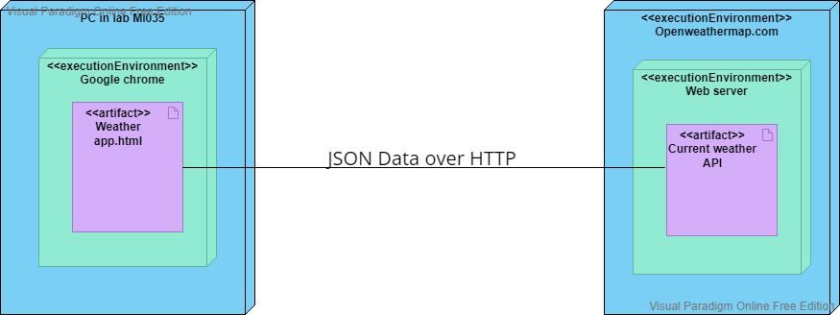

**Architecture:**

Strengths:

The Architecture of the app is made in a very simple way where there is a GET method used by the “Weather app.html” by an API to request the weather details from openweathermap.com.

* It is a plain and direct connection to the server of openweathermap.com which is in Germany, which means no cache on the device.
* We can have the details of any weather conditions of anywhere in the world which is accomplished by minimal amount of coding.
* It doesn’t need anything other than your laptops to run it.

Weaknesses:

* Reliance: Because there is plain and direct connection to the server in Germany, the current app completely relies on the external server. So, if the external server were to stop working or have been made to shut down for either updates or maintenance, this current app as it is would be useless as there won’t be any active server that it will fetch the description of the weather from.
* Security: As there is no security between the weather app and the weather API server, your location isn’t protected and is on the radius of unwanted third parties.
* Pricing: Currently the app runs on a free API with limited number of calls per minute, If our app were to gain momentum and gain couple of hundreds of users and it exceeds the 60 calls per minute you would have to pay for a subscription that essentially does the same thing.